Curriculum Vitae
Of

Md. Sabbir Ahmmed

[All basic information about me are included inside in detail. And all the documents against those information, such as: educational qualification’s certificates, mark sheets, extra curriculum course’s certificate, national ID, birth certificate etc. are attached with this CV in xerox copy. ]

2018

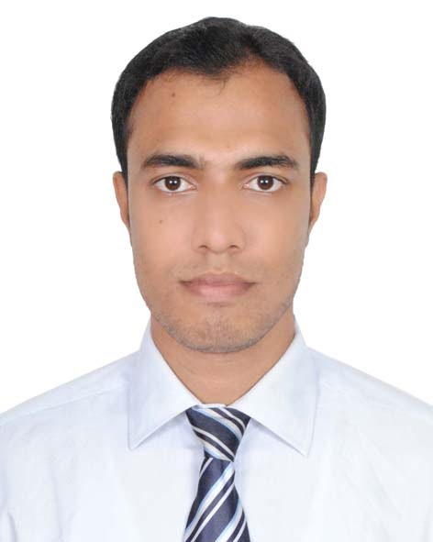

Curriculum Vitae

Of
Md. Sabbir Ahmmed

S/O : Md. Shamim Sarker
Vill : Ekberpur (Purbapara)
Post : Gopigram
P.S : Pirganj
Dist. : Rangpur
Mob: +8801722722224
Email:md.sabbirahmmed@gmail.com

Career Objective

Strong desire to build up a successful career is obtaining a challenging and rewarding position in a reputed organization where I can apply my skill, knowledge and experience to enhance organization’s success and also enhance my personal knowledge and experience with energetic, honest, promised trait, utmost faith and professional mindset.

What Makes Me Different

I am honest & self-motivated, Able to adapt any organizational environment, diligent and ready to give my best effort to achieve the targets. I am a natural team player and I can lead and be led, as the situation requires, I am an optimist by nature and sensible to my concern.

Personal Information:

- Name : Md. Sabbir Ahmmed
- Father’s Name : Md. Shamim Sarker
- Mother’s name : Mrs. Umme Habiba Begum
- Date of Birth : 10/10/1993
- Religion : Islam
- Nationality : Bangladeshi (by Birth)
- Marital Status : Single
- Blood Group : A+
- Permanent address : Vill:Ekberpur,Post:Gopigram,P.S:Pirganj,Dist:Rangpur
- Present address : Chandra, Kaliakoir, Gazipur.

Scholastic Status:

B.Sc in Engineering (Electrical & Electronics Engineering):

Institute : European University of Bangladesh
Department : Electrical & Electronics Engineering
Passing Year : 2017
Result : 3.01 (Out of 4.00)

Diploma in Engineering (Electrical Technology):

Institute : Rangpur Polytechnic Institute, Rangpur
Department : Electrical Technology
Passing Year : 2013
Result : 3.08 (Out of 4.00)
Board : Bangladesh Technical Education Board (BTEB)

Secondary School Certificate (S.S.C):

Institute : Madarganj B.L High School, Rangpur.
Group : Science
Passing Year : 2009
Result : 5.00 (Out of 5.00)
Board : Dinajpur Board

Job Experience:

- Working as a Senior Officer (Production) for Three years (3) at Walton Micro-tech Corporation Ltd. situated at Chandra, Kaliakoir, Gazipur.

My duties are here:
- Production Plan & Run smooth production.
2. Supervision of Production & store.
3. Maintain ORACLE (Database).
4. Maintain Supply Chain.

Extra-Curricular Activities:

a) Training on Sub Station at Rangpur Palli Biddut Samity-1.
b) Good Knowledge on Petrol Engine & Automobile.
c) Gas Generator, Diesel Generator & Engine, Online UPS.

Computer Literacy:

a) MS Office (working experience in MS Excel).
b) SAP & Oracle (Database)
c) Photo & video editing
d) Official & personal mailing (Microsoft Outlook & IBM).
e) Internet browsing etc.

Language Proficiency:

a) Bengali (Mother Tongue): both Verbal and writing.
b) English: both Verbal and writing.
C) Hindi: Verbal.

Interests and Hobbies:

- Playing Badminton, Football, Cricket, Swimming.
- Magazine reading, Watching Documentaries & Art films.
- Tourism.

Hereby, I do assures that the all above informations are true and authority can take any steps against me if they find any information wrong.


______________
Signature
Date: 08-Jan-2018

